Seth Lunas - 033183876
Han Htoo Zin - <insert ID>
Christopher Dominguez - <insert ID>

CECS 327 - Project 1

Dockerfile Steps:

Screenshots:
2. Install Docker
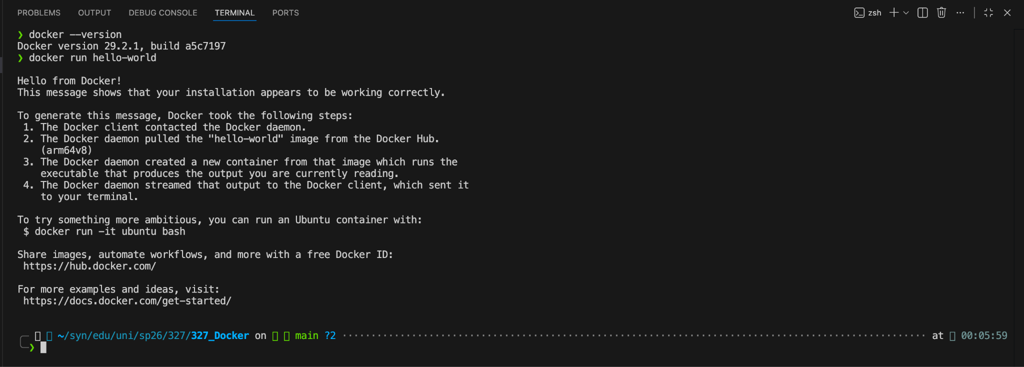
3. Run and explore first container
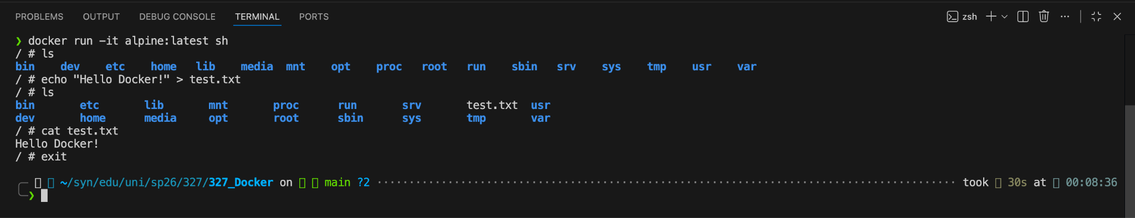
4. Creating a custom Docker image
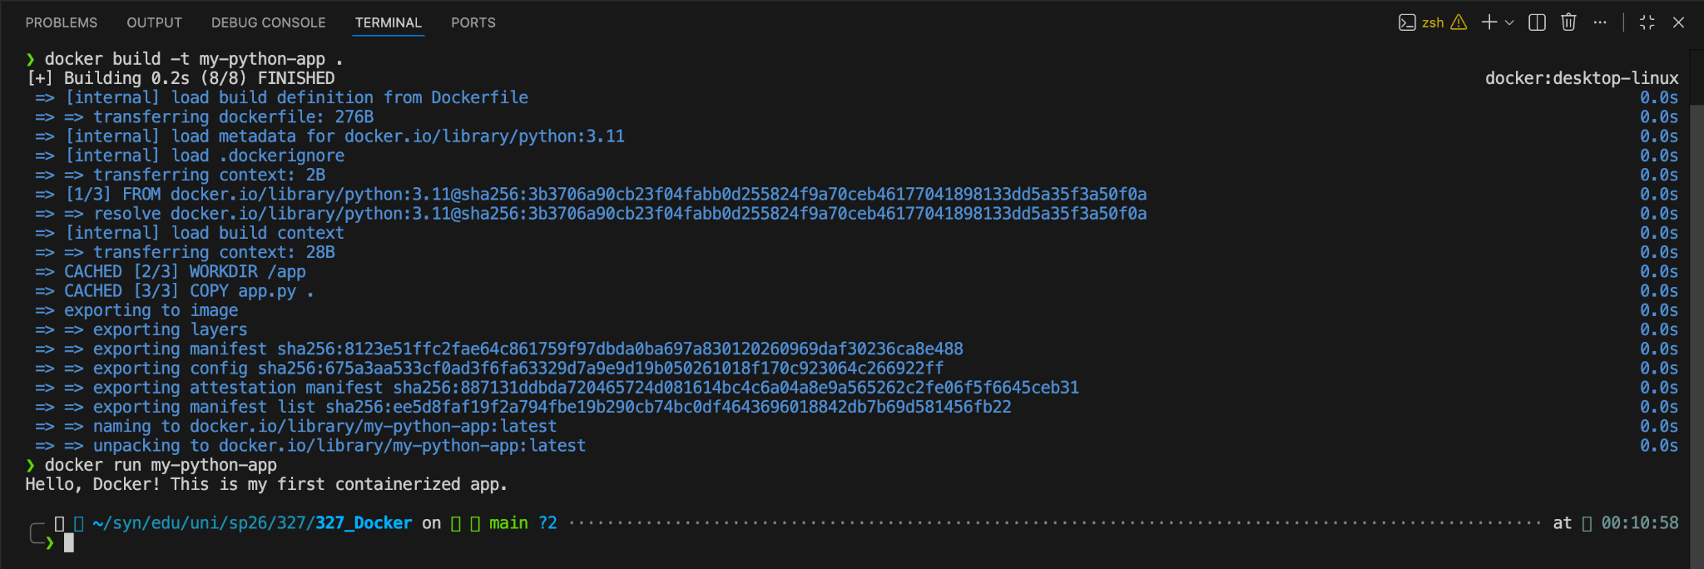

5. Deploying a web server (Nginx)
- Run an Nginx web server using Docker
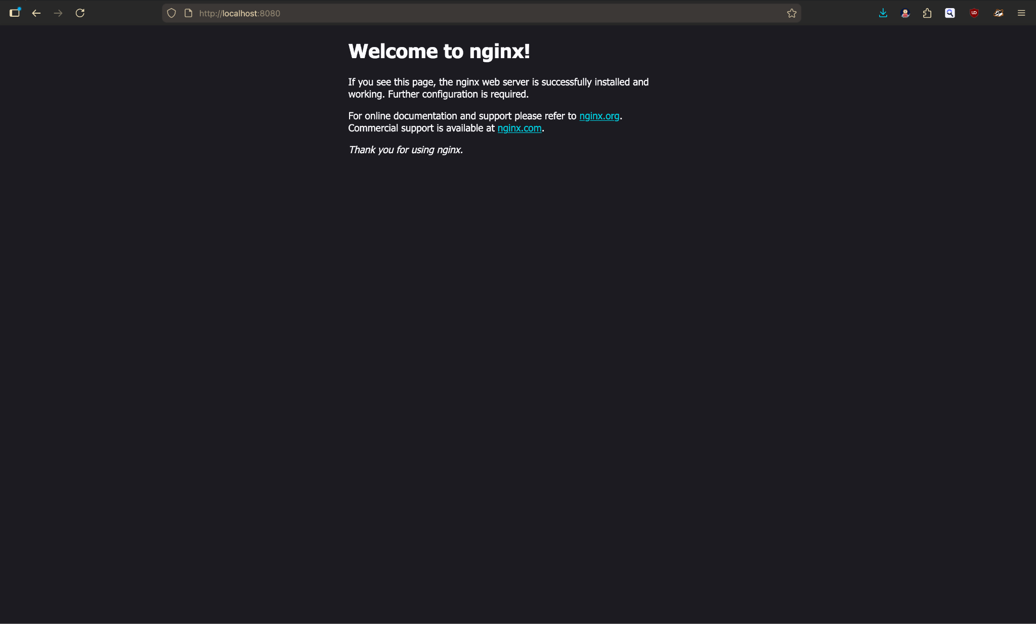
- Modify the default page by mounting volume
